Manufacturing Specification
for BFX-AT100

Document revision:1.1

Effectivity
- 2020.06.08 ~

Prepared by | SH, SON
Prepared by | Manager, Development Lab #2
Approved by | SY, Yoon
Approved by | Head of Development, Development Lab #2

Revision History
Revision | Description of Change | Date
0.1 | Draft release | 2019.07.01
1.0 | Release | 2019.07.23
1.1 | Update for BFX-UH200 | 2020.06.16

Table of contents
1 Purpose of this document 3
2 Manufacturing Specification 3
2.1 Manufacturing process 3
2.2 ECR Process (Change the manufacturing BOM) 4
2.3 Production data Traceability 4
2.4 PCBA Process 4
2.5 Packing 5
3 Test specification 7
3.1 System 7
3.2 Peripheral 8
3.3 Burning 8
4 Quality specification. 9
4.1 Inspection criteria 9
4.2 AQL LEVEL and OBA 9
4.3 OBA TEST ITEM 9
5 Customer special requirements. 12
5.1 SKB serial number 12
5.2 TOP housing protection. 12
5.3 Sample production 13
5.4 Production documents. 13

Purpose of this document
This specification is for manufacturing BFX-AT100 and BFX-UH200. This spec is forced on mass production process, HW component functionality check and validation.

Manufacturing Specification
Purpose:
Defines the overall specifications of the mass production and manufacturing process of BFX-AT100.
Unspecified items follow the Foxconn's standards. But, some of specifications may be changed upon request by the customer.

Manufacturing process
Purpose:
To define the confirmation process of production conditions for each PO or Lot, and Shipment approval process
Process flow:
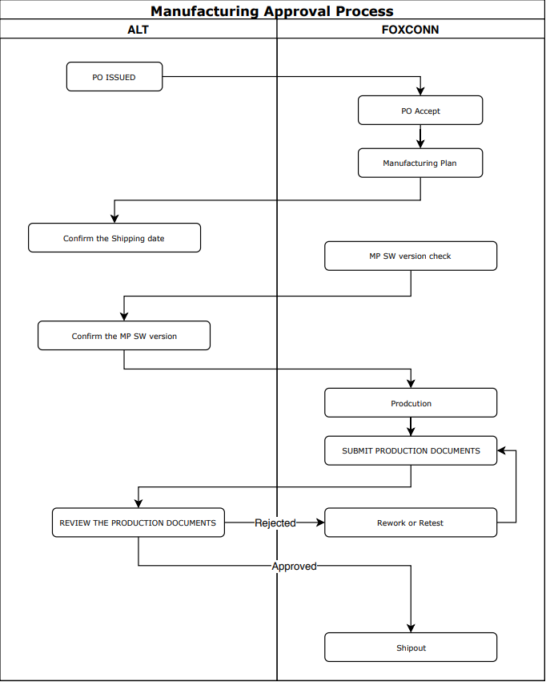
Production Gate
Shipment Gate
see more details following documents.
Attachment 1. “Manufacturing Approval Process_Rev1.0”

ECR Process (Change the manufacturing BOM)
Purpose:
Define the procedures that should be followed when the reason for the part change occurs.
Basically, design and parts changes after final approval are subject to approval by the customer.

Process flow:
// TBD. First, Process discussion and define with ALT and FXN, will be update.
FXN request the ECN to customer.
: PROCESS TBD

ALT or customer request the ECR to FXN
: PROCESS TBD

Production data Traceability
Purpose:
Production data will be used maintain product and quality Prediction. In some cases, production data may be requested by the customer

Criteria:
All production data should be kept up to 3 years after EOL of this product.

PCBA Process
Purpose:
Define the inspection criteria for the PCBA production process.

Criteria:
IPC-A-610 Class 2. Acceptable Condition. More details, please find the IPC-A-610 rev G.
Such as - Soldering and mount, insert conduction, PTH fill up, BGA void, assembly visual inspection.
But, some of acceptable condition may be changed upon request by the customer.

Packing
Purpose:
Define the requirements for product packaging.

    - Labels and Serial number
Criteria:
Should be manufactured according to customer's requirements.
- Each serial number - SET. GIFT, CARTON and Pallet
- Each Labels - SET. GIFT, CARTON and Pallet
Refer to the [Eagle_BFX-AT100] SKB Android TV_UADS in details
Refer to the [Eagle_BFX-UH200] SKB AOSP_UADS in details

    - Gift packing
Criteria:
The packing accessary (in-box items) shall not be missing.
Refer to the production spec document in details - In-Box items

    - Carton packing
Criteria:
One carton box shall be packed in order of SKB number.
Such as 1 carton packed SKB S/N in numerical order 10 pcs.
(AAABBBB001YYYYMMXXXX01 ~ AAABBBB001YYYYMMXXXX10)
<reference>
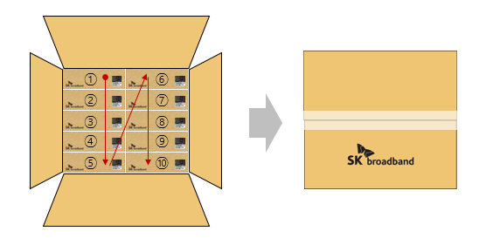

    - Pallet packing
Criteria:
- When pallet packing the carton, carton label barcode should be visible and can be scan
- Inner line do not stack up the carton box
Refer to the [Eagle_BFX-AT100] SKB Android TV_UADS in details
Refer to the [Eagle_BFX-UH200] SKB AOSP_UADS in details

<reference>
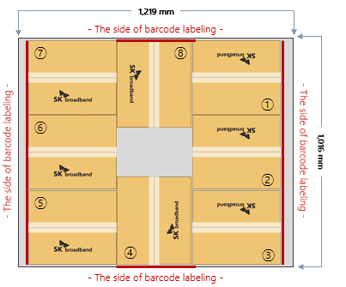
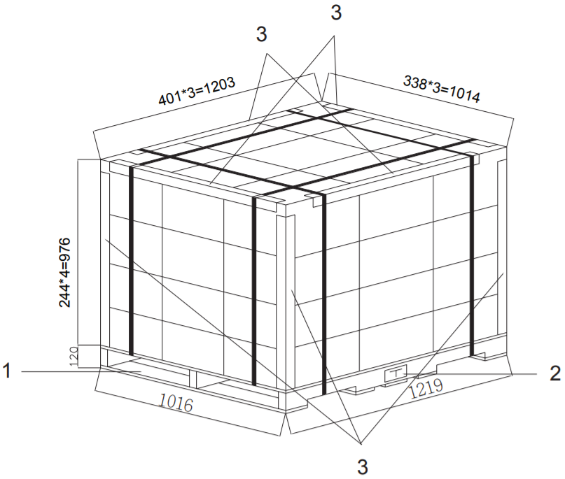
Do not stack up the carton box
Carton label

Test specification
Purpose:
Based on HW requirements form the customer, all product should be tested requirements functions in the factory.

More details, please find the Mantis history.
https://mantis.cnsbg.foxconn.com/vaas/view.php?id=465

System
 | Part | Test item | Criteria
System | SoC | Secure boot | Enabled
System | SoC | OTP Lock | locked
System | SoC | CPU temperature | measurement CPU temperature  - Spec: TBD
System | DRAM | DRAM size check | DDR4 SDRAM 3G - 1GB*2, 512MB*2
System | Flash memory | Check Firmware | Checksum
System | information | MAC: Ethernet, BT | should be unique
System | information | Serial number | should be unique
System | information | SKB Serial number | should be unique
System | information | HDCP 1.4 | should be unique and key validation
System | information | HDCP 2.2 TX / RX | should be unique and key validation
System | information | Widevine LV1 | should be unique and key validation
System | information | Playready | should be unique and key validation
System | information | FW version | Check SW version
System | information | Factory test SW version | Check SW version
System | Software | SKBB SW booting check | Check SKBB Software booting OK

Peripheral
 | Part | Test item | Criteria
Peripheral | HDMI | A/V play output | Check Video resolution: 4Kp60
Peripheral | HDMI | A/V play output | Check the Video and Audio
Peripheral | HDMI | CEC | Check CEC
Peripheral | USB | link speed | Check 2.0 link speed
Peripheral | USB | link speed | Check 3.0 link speed
Peripheral | RJ45 | link speed | Check 1Gbps link speed
Peripheral | RJ45 | Link and Active LED | Check LED (link and active) on/off
Peripheral | 3.5mm MIC Jack | Audio Record | Check Record sound
Peripheral | DC Jack | Connector | Check Adaptor insert
Peripheral | LED | Red | Check Red on/off
Peripheral | LED | Green | Check Green on/off
Peripheral | LED | Blue | Check Blue on/off
Peripheral | LED | White | Check All(RGB) led on/off
Peripheral | IR | IR sensor | Check IR Receive
Peripheral | KEY | CH UP | Check KEY operation
Peripheral | KEY | CH Down | Check KEY operation
Peripheral | Bluetooth | RF Radiation | Check RSSI check
Peripheral | Bluetooth | BT paring | Check paring to BT 4.2 device DUT or BT device

Burning
As is proceed the FXN standard. It can be changed below test condition upon request by the customer.
: Environment and Conditions and burning Q’ty

Quality specification.

Inspection criteria
Purpose:
Define defects and acceptable standards.

Criteria:
Please refer to the following document.
Attachment 2 “BFX-AT100_inspection criteria

AQL LEVEL and OBA
Purpose:
All STB function should be double checked from quality point of view.

As is proceed the FXN standard. It can be changed upon request by the customer.

Criteria:
AQL Level – 1.0 each lot should be passed.

OBA TEST ITEM
Purpose:
All STB function should be double checked from quality point of view.
The OBA test should proceed with the gift box components.

Output:
OBA Test report should be submitted before shipment.

    - Visual inspection
Criteria:
This inspection criteria following the 4.1 Cosmetic criteria. Including accessary package.

    - Check front KEY (CH-/+ Key)
Criteria:
All Key should be work and feel the push sound and feeling of being pressed.

    - Check LED (Power ON and boot or standby)
Criteria:
All LED Color should be turn on the light each color – Red, Green, Blue, White
LED light uniformity on housing should be uniform

    - Check IR Remote Control function (Key Control)
Criteria:
RCU IR transmit and STB IR receive work properly

    - Check Bluetooth Remote Control function (Pairing/Un-Pairing and Key Control)
Criteria:
Bluetooth function should be work properly. – STB volume control, Voice input, Audio streaming
Bluetooth paring and unpairing work properly.

    - Check SW version
Criteria:
Default language: KOREAN
Model name:
Android TV - BFX-AT100
AOSP – BFX-UH200
Software version: depend on each PO or Lot.

    - Check YouTube APP for stream video test.
Criteria:
Stream video play working properly.
: Youtube 4K video play - VP9 codec check, Speed check
: Output resolution check – 3840 x 2160 @ 60hz

    - Check USB port.
Criteria:
USB port should be work properly.
: Check USB 2.0 / 3.0 device detection and device access

    - Check microphone test
Criteria:
Smart Karakoapp –Downing Everysing App form internet for microphone test
-> Skip due to SKB network is not available

    - Check Reset to default function
Criteria:
Factory reset should be work properly.

Customer special requirements.
This customer requirements should be applied BFX-AT100 and BFX-UH200 commonly.

SKB serial number
Purpose:
This serial number management is mandatory requirement form the customer.
More details, please see the Mantis issue ID: 746. (Link)

Criteria:
The SKB serial number range should be matched as ALT noticed serial number range.

TOP housing protection.
Purpose:
To protect the housing scratch, maintain and wrap protective vinyl in gift packing process. Protective vinyl will be removed by end user.
Criteria:
The housing should be protected by a protective vinyl

Protect point:
- TOP of Housing
- Front and both Side.
<Picture >
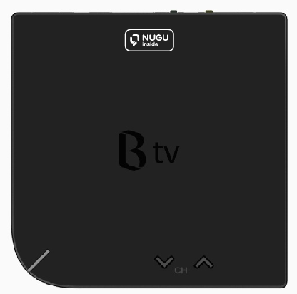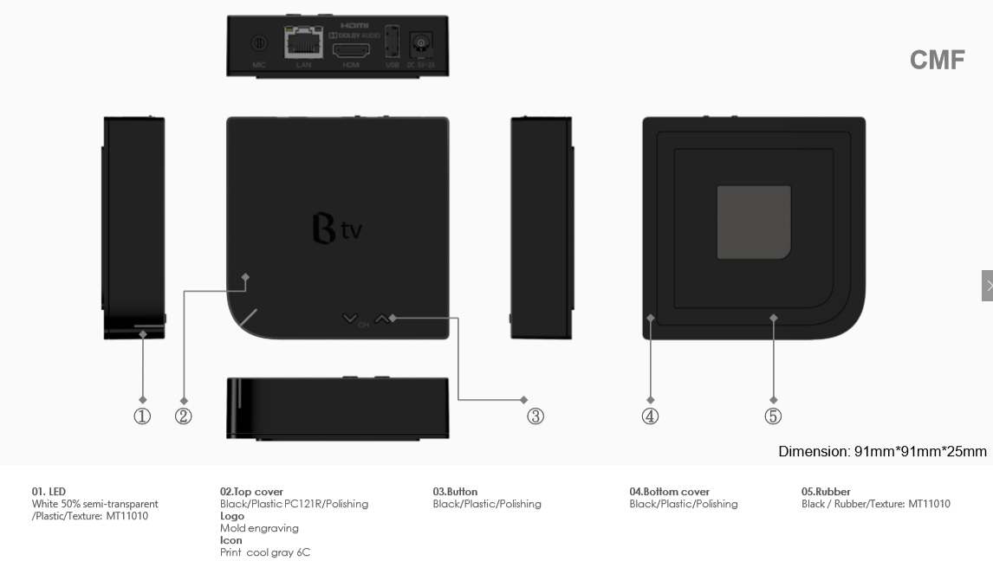
TOP
Front
Side
Side

Sample production
Purpose:
To define SKB S/N range about additional sample PO besides MP PO.

Only use SKB Serial number for sample production.
Each first 16 digit is prefixed value, next 6 digit in order sample production quantity.
ATV BFX-AT100: 2149688001201999000001~2149688001201999999999
AOSP BFX-UH200: 2149687001201999000001~2149687001201999999999

Production documents.
Purpose:
To define production output documents after manufacturing. Factory should be submitted these documents before shipment.

    - Method of transferring
      - e-mailto:
bylee@altech.kr
jwkim@altech.kr
hylee@altech.kr
syyoon@altech.kr
shson@altech.kr
sbpark@altech.kr

      - when
Every shipment

      - Output document list (sample)
Attachment 3 “SN Report”
Attachment 4 “OBA Inspection report_Rev1.0”

